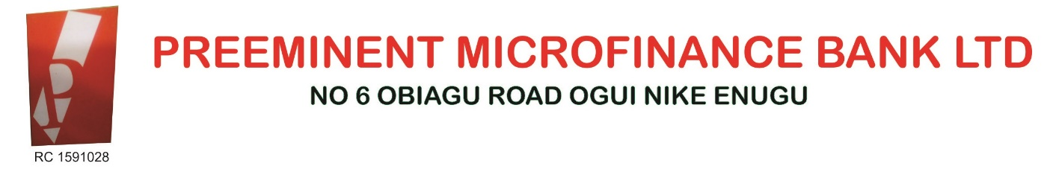

**KYC - CUSTOMER PROFILE**

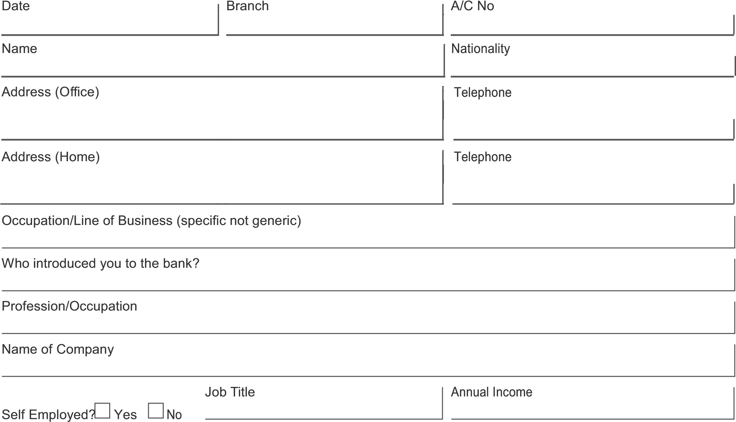

**ADDITIONAL INFORMATION**

Type and source of funds to operate account

Type to operate Account Cash Manager’s Cheque TT/Inward Remittance

|  |  |
| --- | --- |
| If individual | Amount (expected annual) |
| Salaries |  |
| Business income |  |
| Sale of Property |  |
| Others |  |

|  |  |
| --- | --- |
| If Corporate or  Individual in business | Amount (Expected Annual Turnover) |
|  | Trading |
|  | Retailing |
|  | Others |
|  |  |

Source of Funds to operate Account

Client’s Profile



le: Provide a snapshot of customer, source

of funds, expected account activity, background etc.

Relationship Manager……………………………

Account Officer …………………………………



# Anti-money Laundering Risk Management Worksheet

Is the customer’s core business activity one of the defined “High Risk Business” and if so, which?

_____________________________ No

_____________________________ Yes. Management concurs with the “High Risk” assessment and opening the account subject to

High Risk Account Monitoring

_____________________________ Yes. Management judge mentally assesses the account as “Low Risk” (provide justification below)

1. Is the customer located in a “High Risk” geography and/or does the customer deal principally with customer or suppliers who are located in such geographies?

|  |  |
| --- | --- |
|  | |
| _________________________ | No |
| _____________________________  3. Is the customer: | Yes. (List which countries) |
| ______________________________ | A Public Figure? |
| _____________________________ | Expected to handle business activity on the account? |
| _____________________________ | Expected to use High Risk Products? |

If any of 1 -2 is “High Risk”, the classification should be “High Risk”. If adjudged “Low Risk”, then explain.

**JUSTIFICATION/COMMENTS**

RISK

Above

L

CLASSIFICATION High Risk Average Moderate Low

Account Officer

Relationship Manager

## VISITATION REPORT

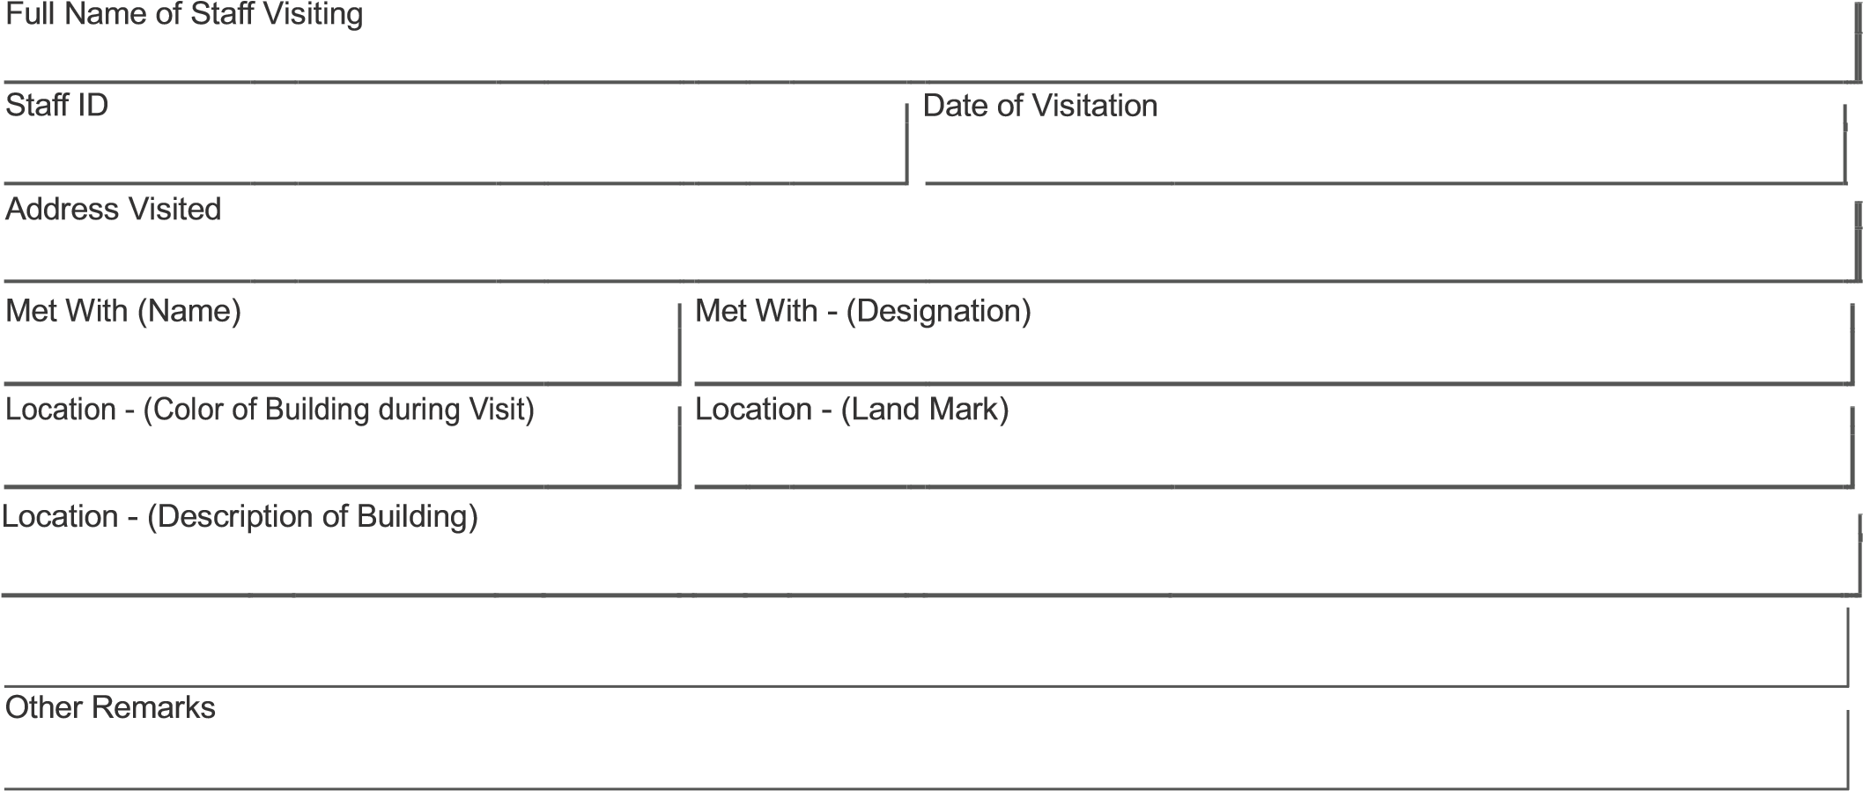

I hereby confirm the existence of the prospective Customers address as stated above.

Visiting Sta

ff

Signature

Date Signed

* Caution: Do not complete Visitation Report if Physical Address verification is not carried out

## VISITATION REPORT



I hereby confirm the existence of the prospective Customers address as stated above.

Visiting Sta

ff

Signature

Date Signed

* Caution: Do not complete Visitation Report if Physical Address verification is not carried out